**Data Visualization Style Guide**

**Knowledge and Insights**

**Enterprise Marketing Hub**

**General rules:**

* Colors used should be ASU colors, with preference for maroon, gold, black, white and grey. Secondary colors can be used when more colors are needed
* Font should be Arial
* Visuals within a report should be consistent. Visuals can be made in Excel, Tableau, ggplot or other software, but ideally the same software will be used for the same type of visuals within a report. This is not a firm rule, but should be followed when possible.
* Time should always go left to right on the axis.
* Graphics should not be square, but should be approximately a 1:1.25 to 1:2 ratio. This comes from our visual preference for the golden ratio.

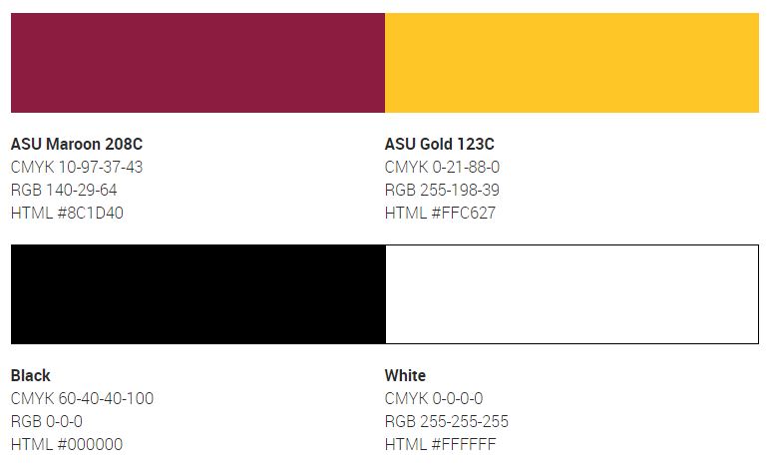

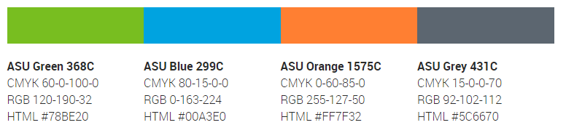

**Displaying one set of numbers in a bar chart:**

* An emphasized number can be in a different color from the rest
* No background lines or very faint background lines only
* No y-axis scale
* Dots or lines can be used for reference.

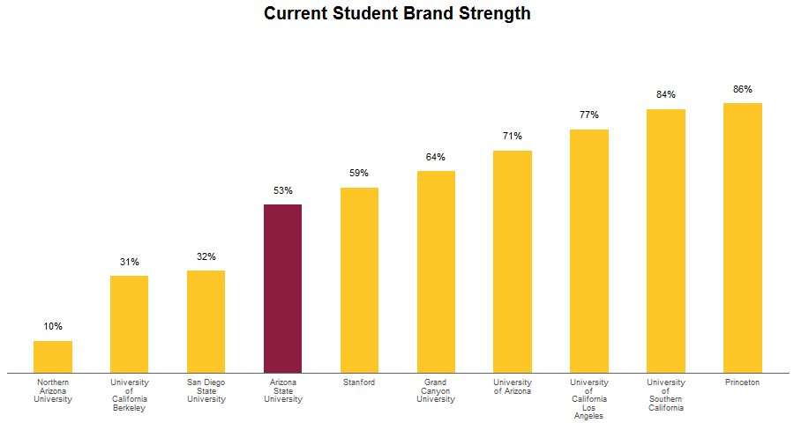

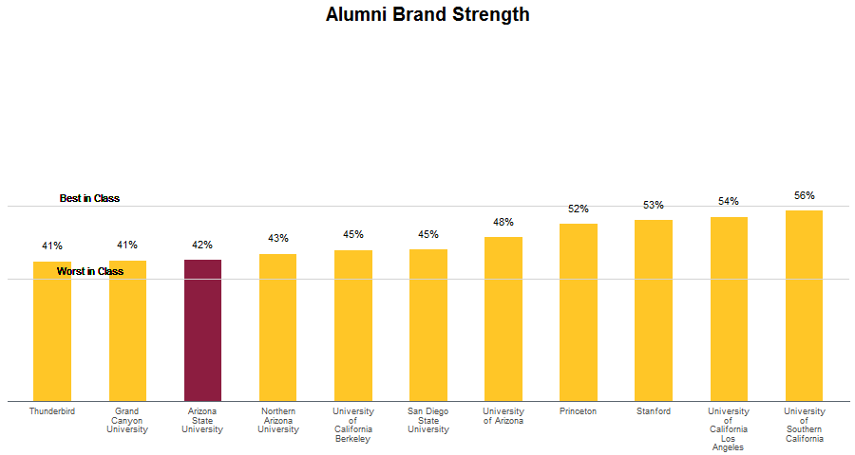

**Displaying two sets of numbers (year over year, or control and treatment):**

* The optimal display is a bar chart
* Non-significant differences should be in grey, while significant differences should be in maroon.
* An emphasized group should be in gold.
* No y-axis scale
* No background lines or very faint background lines only
* Values should be positioned at the top of the bar or along the bottom
* The darker shade should always be on the right and should indicate either the most recent year, or treatment group, or whichever group you want to emphasize.
* Dots or lines can be used for reference.

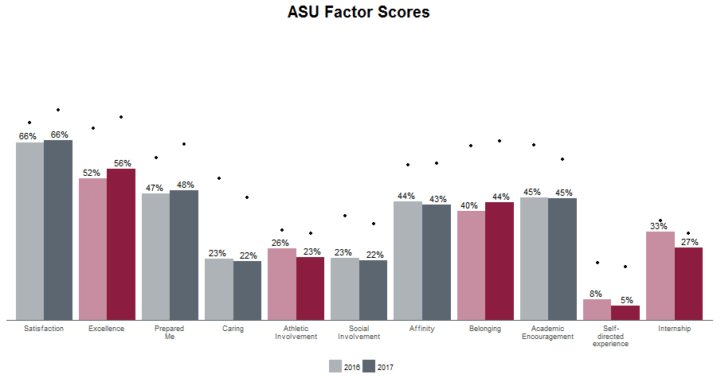

**Displaying more than two sets of numbers (year over year, or control and treatment for two groups):**

* Color should indicate groups, while hue should represent pre-post or treatment-control.
* Dots or lines can be used for reference.

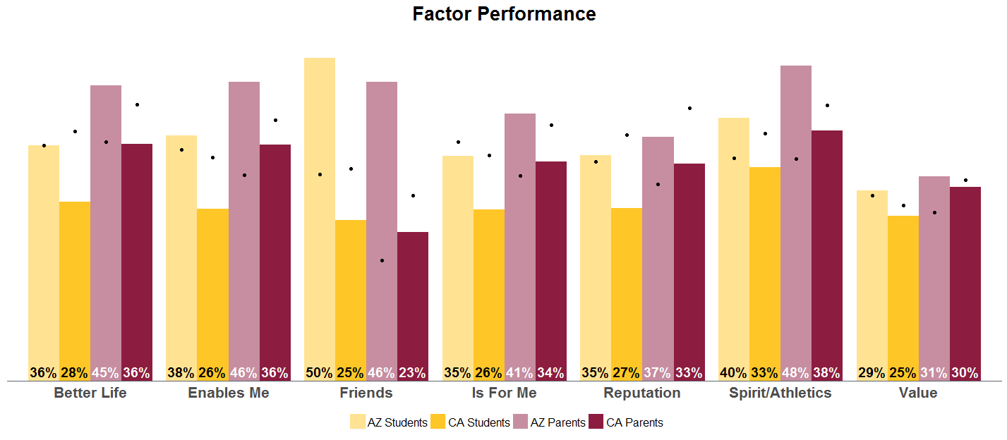

**Direction of the bar graph**

* Using a sideways bar graph can be useful in cases when you have a large number of bars to display or when you have too long of labels.

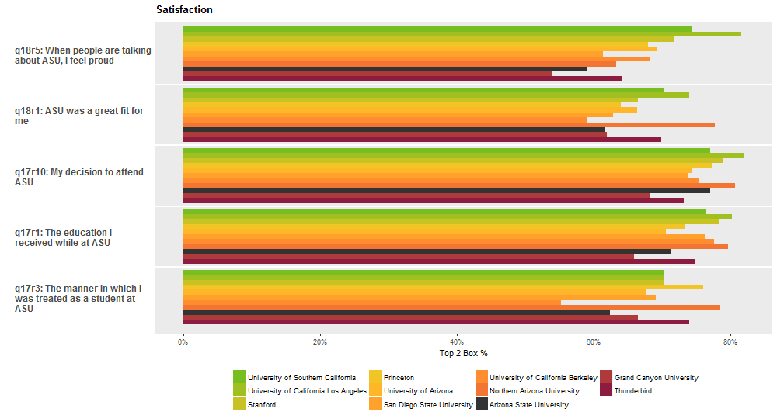

**Displaying more than two groups:**

* When more than two groups need to be displayed, ASU secondary colors should be used.
* Color assignments for each group should be consistent within a given report.
* Color assignments for alumni segments are as follows:

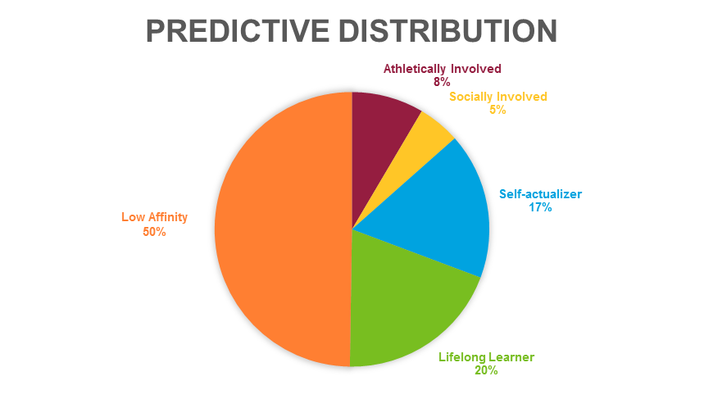

**Displaying high to low differences:**

* Colors should be a gradient from ASU maroon to either ASU green or to ASU blue.

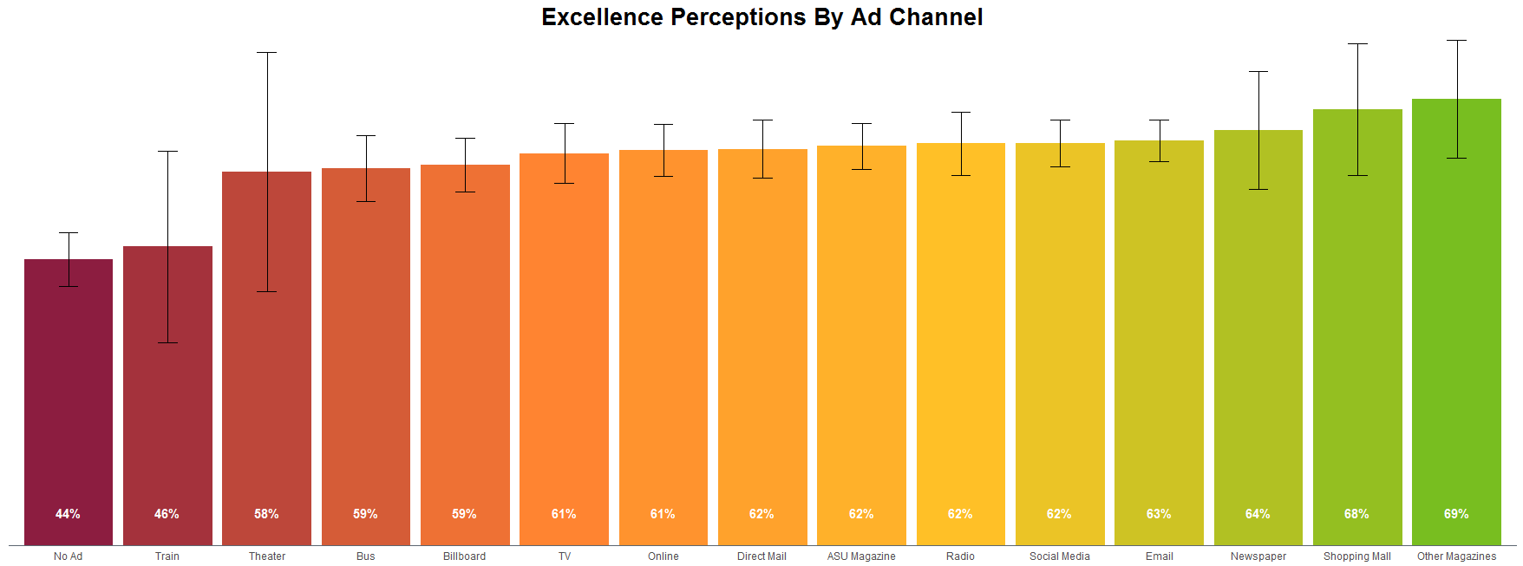

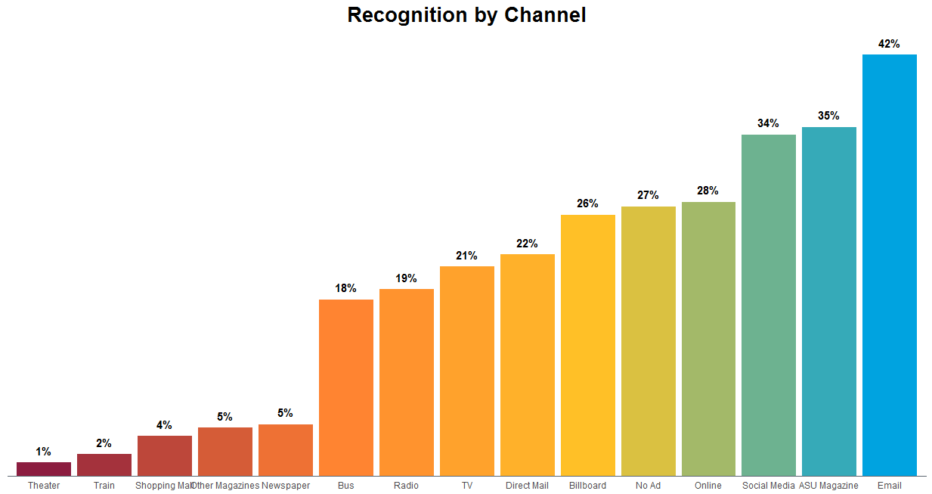

**Line charts**

* Line charts should be used when you are showing information over time, for at least 5 time periods.
* Whenever possible, it is helpful to have multiple lines to provide context unless the pattern in a single line is very striking.